**Lesson 3**

**Line | Circle | Erase | Print | Undo| Rectangle | Multi Line | Extend | Offset | Trim | Introduction to Object Snaps | Creating Selection Sets | Changing your options**

**Line | Circle | Erase | Print | Undo**

AutoCAD allows you to have access to a large number of commands. A general rule is that you will use 20% of the commands 80% of the time. I will start by introducing you to the most common drawing commands. When you combine these with the basic modify commands, you will be able to make elaborate drawings quite quickly. In other words, most of the commands you will use while using AutoCAD are taught in Level 1.

The important thing to remember is that AutoCAD will expect you give it information in a very particular order. The most frustrating thing when you begin using this program is that you will try to do something, but AutoCAD will 'not work'. In most cases, it means that you are trying to input information at the wrong time. This is why it is **very important** to be in the habit of looking at the command line.

**The command line tells you what information AutoCAD requires to continue.**

Your first drawing assignment will be to use the drawing commands in conjunction with the co-ordinate system defined in **Lesson 2**. This is a basic assignment, but it is very important to understand how to give the program accurate information. You will use the following commands:

|  |  |  |  |  |
| --- | --- | --- | --- | --- |
| **Command** | **Keystroke** | **Icon** | **Location** | **Result** |
| Line | Line / L | Line Icon | Home >Line | Draw a straight line segment from one point to the next |
| Circle | Circle / C | Circle Icon | Home>Circle >Centre, Radius | Draws a circle based on a centre point and radius. |
| Erase | Erase / E | Erase Icon | Modify >Erase | Erases an object. |
| Print | Print / Plot CTRL+P | Plot Icon | Quick Access Toolbar > Print | Enables the Print/Plot Configuration Dialog Box |
| Undo | U / CTRL+Z | Undo Icon | Quick Access Toolbar>Undo | Undoes the last command. |

**Exercise**

***Drawing lines to exact points***

You will not have to worry about the title block or text, or dimensioning.

Make sure you are comfortable with the co-ordinate system as explained in Lesson 2. When you are finished this assignment, check the printed drawing with a scale ruler. All lines should measure up exactly if all went well.

***Steps:***

Start AutoCAD and a new drawing by pressing the Application Button (top left corner) and pressing the new button to reveal the flyout. Once you see the flyout, click on Drawing.

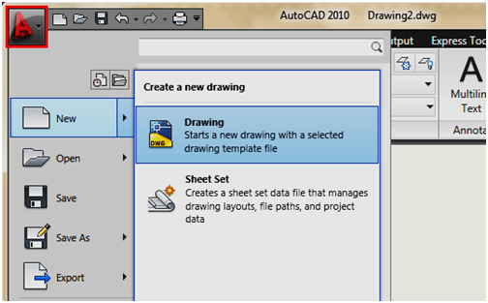

You will see a dialog box open that asks you to select a template drawing to use (as shown below):

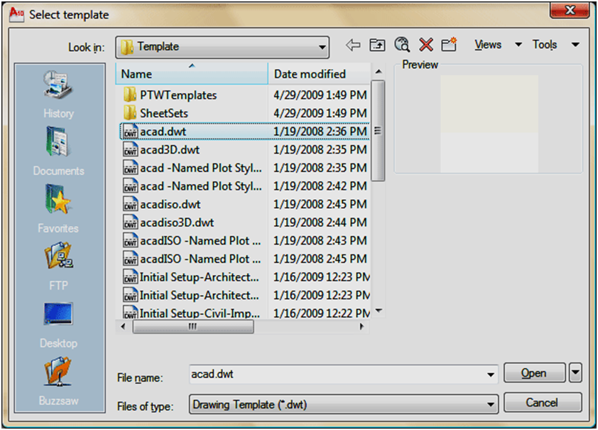

Select the "acad.dwt" template file and press the Open button to continue to the drawing screen.

Once there, type in Z <ENTER> E <ENTER> this will zoom into to the extents of the drawing area and make it easier to see what you are drawing (NOTE: nothing will appear to happen).

For all lessons on this level, make sure that you do not have Dynamic Input turned on. You can check this on the status bar. Make sure  (the DYN button) isn't depressed. Your status bar buttons (bottom of the screen) should like the image above with 3 icon pressed (in blue).

Start the LINE command (as explained in the table above) and draw a line from 1,2 to 3,2 to 3,4 to 1,4 Press enter after each point. (*Remember to watch the command line as you do this.) For the last line, you can either type in 1,2 or C to close the line back to the first point you entered. You have just drawn a 2" square using absolute co-ordinates. Your command history (F2 key) should look like this:

Command: L LINE Specify first point: 1,2

Specify next point or [Undo]: 3,2

Specify next point or [Undo]: 3,4

Specify next point or [Close/Undo]: 1,4

Specify next point or [Close/Undo]: 1,2

Specify next point or [Close/Undo]:<ENTER>

If you make a mistake, you can use the undo icon, press U or press CTRL+Z.

You can also use the ERASE command to get rid of lines you don't want.

Next draw a similar box using relative co-ordinates. Start the LINE command and begin at point 4.5,2. From there draw a line two units to the right by typing @2,0 (this means 2 units in the X direction, 0 units in the Y direction based on the last point you entered). Next type @0,2 then @-2,0 then @0,-2 to finish the box. (Remember to press enter after each point.)

Now erase the last box you just drew. Start the ERASE command and then select the lines you want to erase. Then press <enter>. Now redraw the box for more practice!

Draw a third box using polar co-ordinate input. Start the LINE command and begin at point 8,2 then enter. Type @1<45 to draw the first line. Next enter @1<135 then @1<225 then @1<315 (or C to close). What you have just done is drawn a line 1 unit long at 45o, then another at 135o and so on. Do the angles you entered make sense to you? If not, review it.

Start the CIRCLE command and add a circle that has a center point at 7,6 with a radius of .75 (Watch the command line for instructions).

To finish the drawing, try putting a 10"x7" border around the page starting at 0,0 using the any of the methods shown above (relative, absolute or polar).

***Print***

When you have done this you can print (or plot) it out. To do this, bring up the plot dialog box using any method explained above (plot <enter> will work). Set it up to print as shown below. Follow these steps for a successful plot (see diagram below):

1. Select your printer - laser or inkjet will work fine.

2. Select the paper size - "Letter" ( 8-1/2" x 11") is needed in this case.

3. For the "Plot Area", select "Extents" - that will plot everything you drew.

4. Select the checkbox to "Center the Plot" on your sheet of paper (looks better).

5. If "Fit to Paper" is selected by default, uncheck it and select a scale of 1 inch to 1 paper unit (1:1). This will make your printout 'life-sized'.

6. Now Preview your drawing. I strongly recommend that you preview EVERY drawing you will ever draw in AutoCAD - a lot can go wrong, so you don't want to waste paper (especially when you're using expensive 3'x4' sheets!).If your preview looks good, cancel out of it by clicking on the large red X icon.

7. If you're sure that everything's ok (this is where good habits begin), press the OK button.

**Note:** You may have to change the paper size in your printer (Use the Windows printer settings to do this.) You may also have to change the rotation or origin of the plot. Check the Landscape radio button in the Drawing Orientation section.

If everything worked out, you should be able to measure your drawing and have it exactly the way you drew it (a couple of 2" squares, an angled 1" square and a 1-1/2" circle).

Save your drawing as you would any other Windows file. CTRL+S will bring up the Save or Save as dialog box.

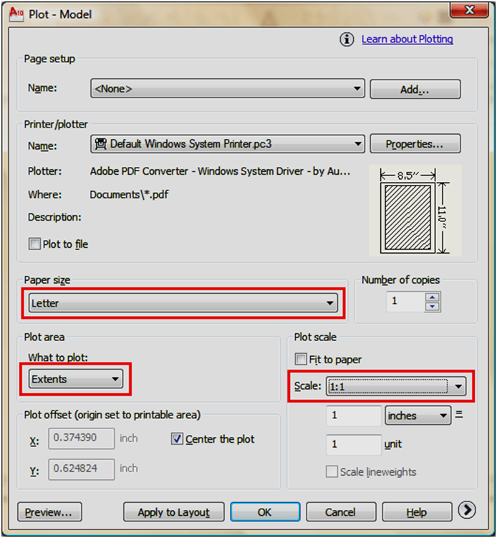

**Rectangle | Multi Line | Extend | Offset | Trim | Introduction to Object Snaps**

The previous lesson dealt with drawing commands. This lesson will introduce some common modifying commands. In AutoCAD, you may actually use modifying commands more often than drawing commands. Now that you know the basics, here's some more commands to add to your collection. Three commands, Trim, Extend and Offset are used standard AutoCAD work.

|  |  |  |  |  |
| --- | --- | --- | --- | --- |
| **Command** | **Keystroke** | **Icon** | **Location** | **Result** |
| Rectangle | **RECTANGLE /**  **REC** | Rectangle Icon | H ome> Draw > Rectangle | Draws a rectangle after you enter one corner and then the second. |
| Trim | **TRIM / TR** | Trim Icon | Home > Modify > Trim | Trims objects to a selected cutting edge. |
| Extend | **EXTEND / EX** | Extend Icon | Home > Modify > Extend | Extends objects to a selected boundary edge. |
| Offset | **OFFSET / O** | Offset Icon | Home > Modify > Offset | Offsets an object (parallel) by a set distance. |
| Object Snaps | OSNAP / OS / F3 | CLICK  Osnap toggle on the Status Bar | Tools > Object  Snap Settings | Brings up the OSNAP dialog box. |

***Exercises***

***Modifying Commands***

The purpose of this assignment is to use the commands learned in the previous lesson and learn some new ones.

Once again, do not worry about title blocks, text or dimensions, draw only what is in yellow.

Start AutoCAD and begin the the drawing by opening up the template file like you did in Lesson 1-2.

Draw a **LINE** from **1,2** to **3,2** to **3,4** to **1,4** (**\*Remember to watch the command line as you do this.)** For the last line's endpoint , you can either type in **1,2** or **C** to close the line back to the first point you entered. These are **absolute coordinates.** Make sure you understand what the points your just entered represent.

Draw the next square using the **RECTANGLE** command. A rectangle is created by specifying 2 points to represent the opposite corners. Enter the first point as 4.5,2 and then make the opposite corner 2 inches over and 2 inches up @2,2 using **relative coordinates.** This is much faster and also makes the square **one object** and not 4 separate lines.

**ERASE** the rectangle. You will see that all of it is gone with **one pick**. Redraw it and continue.

For the 3rd square, draw a 1.5 x 1.5 unit square using any of the methods you know. The bottom left corner must be a 8,2.

Draw a line from **2,5** to **2,6.5** Draw another line from **1,6** to **3,6** You should now have two perpendicular lines. What you want to do is trim off the top of the vertical line and create a T.

Start the **TRIM** command. It will first ask for a cutting edge. Select the horizontal line and press <ENTER>. It will now ask for the object to be trimmed. Select the vertical line anywhere above the horizontal (cutting) line and press <ENTER> to finish the command.

This is what you saw on the command line:

Command: TR <enter> TRIM  
Current settings: Projection=UCS, Edge=None  
Select cutting edges ...  
Select objects: <Select the Horizontal line> 1 found  
Select objects: <enter>  
Select object to trim or shift-select to extend or [Fence/Crossing/Project/Edge/eRase/Undo]:<Select the vertical line>  
Select object to trim or shift-select to extend or [Project/Edge/Undo]: <enter>

Once again, it is important to keep your eye on the command line as it will guide you through most commands.

Draw a LINE from **4,6.5** to **6,6.5** Draw another line from **5,5** to **5,6** What you want to do now is **extend** the vertical line up to the meet horizontal line. Start the **EXTEND** command. AutoCAD asks for a boundary edge; select the horizontal line press <ENTER>. It then asks for an object to extend; select somewhere in the top half of the vertical line. Press <ENTER> to end the command. Your command line history should match what is shown below.

Command: EX **<enter>** EXTEND  
Current settings: Projection=UCS, Edge=None  
Select boundary edges ...  
Select objects: **<Select the horizontal line>** 1 found  
Select objects: **<enter>**  
Select object to extend or shift-select to trim or [Fence/Crossing/Project/Edge/Undo]:**<Select the top half of the vertical line>**  
Select object to extend or shift-select to trim or [Project/Edge/Undo]: **<enter>**

Draw a CIRCLE with a center point of **7.5,5.5** with a radius of **.5** Now you will use to offset command to make another circle 1/4" larger. Start the **OFFSET** command (watch the command line) and enter **.125** as the offset distance (1/2 of 1/4"). Now select the circle and pick anywhere **outside** the circle. Press <ENTER> to end the command.

**Object Snaps**

Suppose you want to draw a line from the center of the circle to the middle of the vertical line you extended earlier. AutoCAD has a feature that makes this very easy. These are the Object Snaps (or Osnaps "Oh-Snaps"). Type OS <ENTER> . You will see this dialog box appear.

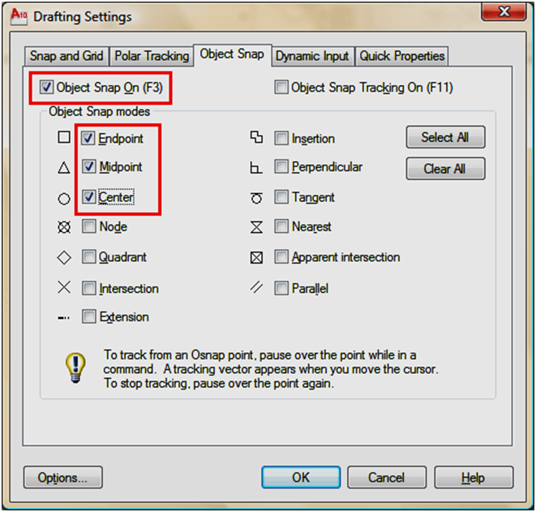

You may select whichever points you want to 'snap' on an object. Here is a list of your options. Followed by the command entry to invoke the needed Osnap.

**Endpoint** - snaps to either the beginning or the end of an object such as a line - END

**Midpoint** - snaps to the exact middle of a line or an arc - MID

**Center** - snaps to the center-point of a circle or arc - CEN

**Node** - snaps to 'nodes' (not covered in this course) - NOD

**Quadrant** - snaps to any of the four quadrants of a circle - QUA

**Intersection** - snaps to the point where two object cross - INT

**Extension** - Snaps to the phantom extension of an arc or line - EXT

**Insertion** - snaps to the insertion point of an object (such as a block or text) - INS

**Perpendicular** - will snap so that the result is perpendicular to line selected - PER

**Tangent** - snaps to create a line tangent to a circle or arc - TAN

**Nearest** - will find the closest point an object and snap to that point - NEA

**Parallel** -Snaps parallel to a specified line - PAR

**M2P** - This isn't technically an 'Object Snap' as you are not snapping to specific point on an object, but it allows you to select 2 points and it will calculate the midpoint between those 2 points. This is a very handy option to have.

***Exercise***

**Note:** Beside each checkbox is a symbol. That symbol will show up on the screen when you have found a valid snap point. (An endpoint will show a small square). If you select the "Options" button, you can change the aperture size and the color of the Osnaps. Depending upon the background you are drawing on, this may be needed.

1. Check off the boxes as shown in the dialog box above (Object Snaps On, Endpoint, Midpoint, Center) and press OK.
2. Begin the LINE command. Move your cursor around the screen and you'll see that as you get close to an object, it will 'snap' to one of the points that you had checked off in the dialog box. Place your cursor on the circle (not the middle of the circle) until you see a small purple circle appear at its center. Left-click to make this the start point of the line. Move the cursor towards the middle of the vertical line until you see a small triangle appear. (Remember this is the symbol for 'midpoint'). When you see it left-click to accept this as your endpoint. Press <ENTER> to end the line command.
3. Save your drawing.

**TIP**: Before you select the Osnap you want, you can press the TAB key on your keyboard to cycle through the available Osnaps in the area of your cursor.

**CAUTION**: Although it may seem tempting to turn 'all' the Osnaps on when drawing, you can have too much of a good thing. For example, in shorter lines, Midpoint, Nearest and Perpendicular could all be very close to each other, and you could select the wrong point.

When you have finished the assignment, continue practicing with the commands until they are mastered. These are common commands that you will use in everyday drafting.

**Creating Selection Sets | Changing your options**

By now you have probably seen a colored rectangle appear on your screen when you left-click and the move the crosshairs around. You'll learn all about these in this lesson. AutoCAD uses what's called a **selection set** to allow you to group objects together and then modify them. For example, if you want to erase several lines, you could press E <ENTER>, pick on the line, press <ENTER> again and repeat until you're done. Another way would be to press E <ENTER>, and then pick the lines one by one until they are all selected, and press <ENTER>. By selecting a group of objects, you have created a selection set. Whenever you want to modify an object, and are asked by AutoCAD to "**select objects**" you can create a selection set and then apply the command.

REMEMBER TO PRESS **ENTER** WHEN YOU ARE FINISHED SELECTING THE OBJECTS

There are also a few other ways to create a selection set. The most common way is to use a window.

**There are two very different types of windows you can use.**

One is a *'crossing window'* and the other is a *box*. If you create the window from **right to left**, you make a crossing window. This means that any object that crosses the border or is surrounded by the window is added to the selection set. This is shown as a green rectangle with a dotted outline on the screen. If you create the window from **left to right**, you create a box. Using this method you'll add only the items that are completely within the box. This is shown as a blue box on the screen. **The difference is very important. More Info**

To summarize:

|  |  |  |  |
| --- | --- | --- | --- |
| **DIRECTION** | **CALLED** | **DISPLAY** | **EFFECT** |
| RIGHT TO LEFT | CROSSING SELECTION | GREEN  (with a dotted outline) | SECLECTS ANY OBJECT THAT EITHER CROSSES THE BOUNDARY OR IS INSIDE IT |
| LEFT TO RIGHT | WINDOW SELCTION | BLUE | SELECTS ON OBJECTS THAT ARE COMPLETELY WITHIN THE BOX |

There are other ways to select objects and here a few of the more common ways. These can also be used in combination.

**REMOVE** - by typing R when asked to select objects, AutoCAD will select change to allow you to Remove objects from the selection set. You can also remove individual objects by pressing the Shift Key when selecting (known as a 'shift-select')

**LAST** - by typing L when asked to select objects, AutoCAD will select the last object that you created. This is handy if you create something and want to move or modify it right away.

**PREVIOUS** - by typing P when asked to select objects, AutoCAD will select the previous selection set. This is used if you select a few objects, modify them and then want to modify them again.

**FENCE** - by typing F when asked to select objects, AutoCAD allows you to draw a series of lines (called a fence) to select objects. This is convenient if you want to select a group of lines to be trimmed to a single cutting edge.

**CROSSING POLYGON** - typing CP when you are selecting objects give the ability to create a crossing polygon for object selection. This is similar to a crossing box (drawn like a Fence), but you can pick points on the screen to create a polygon. By default, this is a crossing polygon, therefore any objects that cross the polygon will be added to the selection set.

**CROSSING WINDOW** - typing WP (window polygon) when you are selecting objects give the ability to create a crossing window for object selection. This is similar to a crossing box, but you can pick points on the screen to create a polygon. This is a crossing window, therefore any objects that are completely within the polygon will be added to the selection set. Newer versions of AutoCAD allow you to use your cursor to create a crossing window without typing in the 'CW'.

**CYCLING** - When are ready to select objects, hold down the Shift key on your keyboard and then press the Space Bar when your mouse is on top of overlapping objects. Repeatedly press the Space Bar until the one object you want to modify is highlighted. Then pick with the mouse. This is a good approach if you have many objects in a small area.

To deselect everything you have selected, you just press the escape key on your keyboard or right-click and choose "Deselect All" from the menu.

**TIP**: Zoom in when selecting in tight spaces. Make sure you are 100% sure you are selecting the correct object. Imagine the difference of offsetting an interior wall instead of the exterior wall - the resulting object would be off by over 6 inches! Get used to zooming in, then zooming out quickly.

You need to quickly select objects in AutoCAD to be a good operator.

**Changing your selection options**

Many people are happy with the default AutoCAD settings. Sometimes you might want to change your settings for things like your grip or pickbox size. This is totally personal and it's your call. I'll show how to change these, but remember where the settings are in case you want to change them back.

Type in OP for Options and look for the Selection tab. You'll see a dialog box that looks like the one below.

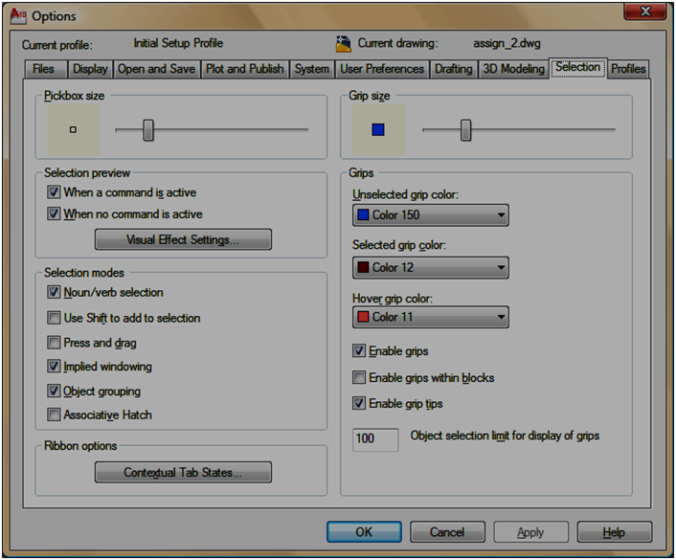

As you can see, you can customize a few things. Think about having a drawing that has a lot of blue lines in it. If you want, you can change your grip color so that they are clearer. Some people like a larger pickbox size, but I prefer a smaller box that is more precise. Another option that is used a lot is "Enable grips within blocks" - you'll learn about grips and blocks in later lessons.